ASHBURY SILENT AUCTION FUNDRAISER
Bids should be submitted using the Bidding Form to Judy Clarke (Winslow Coombe opposite the village shop) or Margaret Smith (Church Lane Bungalow behind the pub) in a sealed envelope – with the lot number on the front of the envelope, by noon on Fri 27 Nov.
GOOD LUCK!
LOT NO | ITEM DESCRIPTION | Donated by
1   | TOUR of ASHBURY MANOR WITH TEA  An afternoon hour-long historical tour of Ashbury Manor for up to four people with tea in the walled garden (weather permitting). All Covid-19 rules to be respected. On timing, May 2021 recommended for best viewing of the garden. | Christopher and Nina Prentice
2   | VIRGIN WINE  With the holiday season upon us, you might like some extra wine. As a member of Virgin Wine club, I am offering a half case of wine of your choosing. You can look at the wine club online and see what options there are, or join me for an ordering session! Wine will be delivered to me and I will let you know as soon as it arrives. | Gail Loose
3  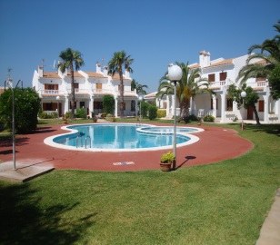 | ESCAPE TO THE SUN  One week’s accommodation in a Spanish Villa on the beautiful Costa Azahar.  2 bedrooms, 2 bathrooms, fully fitted kitchen.  Garden Setting, 200m from the beach. Communal Pool & tennis court  Dates to be agreed between us. | Graham & Judy Clarke
4   | THREE COURSE DINNER for up six people  A home cooked three course dinner to be brought to your door (within local area) – the menu and date to be agreed between us. | Margaret Smith & Maggie Simons
5  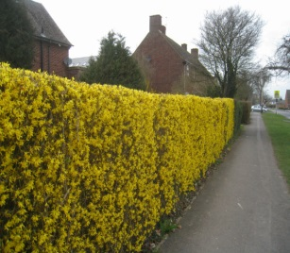 | HEDGE TRIMMING  Do you have an unruly hedge that needs a trim? James is happy to tackle most hedges but not the very high ones! He is willing to spend a day helping out. | James Reade
6   | HISTORICAL WALK around MINSTER LOVELL with cake!  An entertaining guided walk which will reveal the fascinating history of Old and New Minster Lovell from the ancient celts through to the Royal Lovell family, meeting on the way the ghostly white lady and Fergus O'Connell the Chartist. Followed by coffee and cake sitting by the River Windrush. For up to six people on a date to be agreed. | Stewart Smith
7  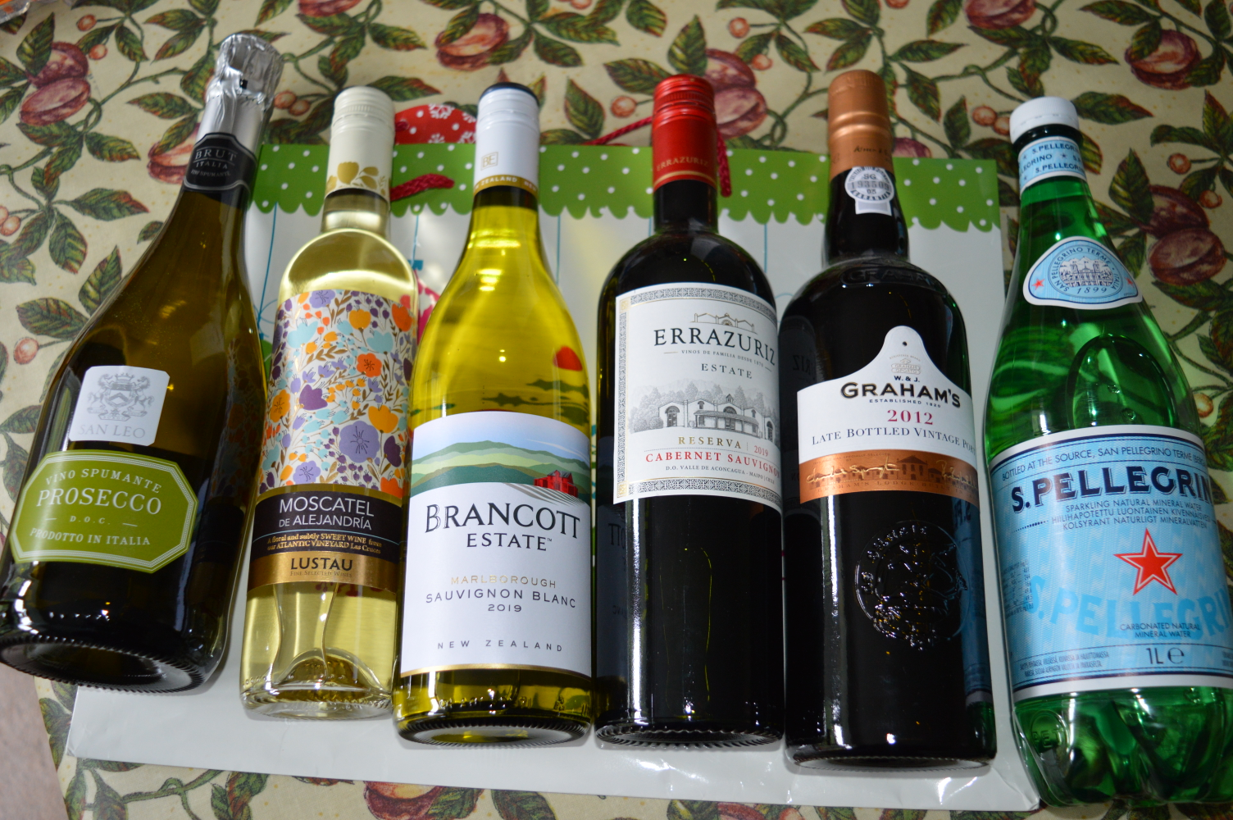 | WINE FOR CHRISTMAS  Six bottles - perfect for Christmas Day!  Prosecco San Leo, Brancott Estate Sauvignon Blanc, Errazuriz Cabernet Sauvignon, Graham’s LBV port, Moscatel de Alejandria (half bottle), San Pellegrino for the driver. | Norma and Richard Fergusson
8  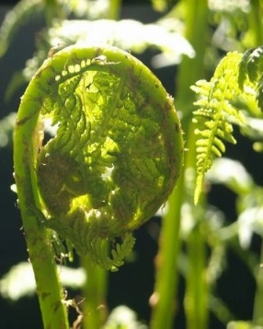 | BEAUTIFULLY DESIGNED CARDS BY ICKNIELD ORIGINALS  Mixed pack of 10 cards worth £20 with envelopes to use all year round, blank for your own message.  https://icknieldoriginals.co.uk/ | Eliza Lewis
9  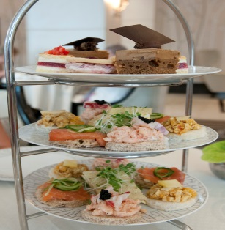 | AFTERNOON TEA for up to six people  Enjoy sandwiches, scones with clotted cream and jam and a selection of cakes. The food will be delivered to your door (within local area) at a date and time to be agreed. | Margaret Smith & Maggie Simons
10  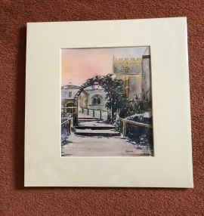 | WATERCOLOUR PAINTING OF ASHBURY CHURCH  A mounted original water colour painting of St Mary's Church, donated by the artist (who runs the monthly water colour painting session in the hall). The painting size is 30 x 40 cm | Hilary Sinclair
11  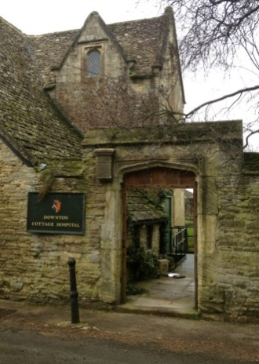 | DOWNTON WALK THROUGH THE OLDEST TOWN IN ENGLAND  Guided walk along the Downton Mile, visiting the Church where Lady Mary got married. See where the oldest street fair and horse fair was held. Learn about the story of Bampton, from Manor Farm through leather work and the ancient salt trail. Easy walking of up to 90 minutes. For up to six people on a date to be agreed. | Stewart Smith
12   | ENJOY AN EVENING UNDER THE STARS WITH ASHBURY'S VERY OWN ASTRONOMER  You will get a guided tour of the night sky and will learn how to navigate the stars and identify constellations, the Milky Way, planets and other objects just using your eyes. While we stargaze you will hear some stories and mythology of the night sky. We may also be able to see some of these objects through a telescope weather permitting. Above all, we will have an evening of fun.  Session duration: 90 minutes. Time and date: To be arranged. Suitability: Ages 8+ for a group of up to five people. | Adrian West
13   | CV ADVICE & PREPARATION  Are you a young person trying to get your first job, a mum looking to re-enter the workplace, an executive trying to pivot to the next thing? You are never too young or too old to benefit from a bit of career coaching. Anica has mentored everyone from secondary school students to executives, and after years taking care of the home successfully got herself back into work. She is happy to speak with you about what you would like to achieve: to help you tease out skills or experience you might not realise you had, take a look at (or help you write your first) CV, to think laterally about your future, and to give you some really practical tips to achieve your goals. (For those of you already happily in employment, this might be a nice Christmas gift for a friend or grandchild.) Anica says she is happy to do a further CV help for the 'under-bidder'. | Anica Alvarez Nishio
14   | IRONING  Two hours of ironing, I'm slow but very thorough. Please avoid specialist materials which need extra care. | Julia Blake
15   | LANGUAGE DEVELOPMENT AND SPEECH ASSESSMENT  Assessment and advice for a 2-3 year old with delayed language development or a speech assessment for an older child. | Julia Blake
16   | GARDEN TIDYING  Two hours of garden tidying, weeding, pruning, etc. I will be unable to dispose of rubbish. | Julia Blake
17   | DOWNLAND EVENING WALK WITH SUPPER  Join Dickie & Penny Green for a June downland evening walk and supper to identify orchids and flowers for 2 people. | Dickie & Penny Green
18 | GARDENING  A day's maintenance gardening, or two half days (8 hours), within 5 miles of Ashbury on a date/s to be agreed.  Anytime within the next 9 months. Donated by Joseph Weller (07802 735 912) | Joseph Weller
19  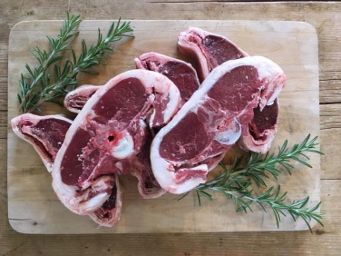 | HALF LAMB MEAT BOX  Delicious local lamb, chops and joints ready for the freezer. | Sally-Ann Spence
20  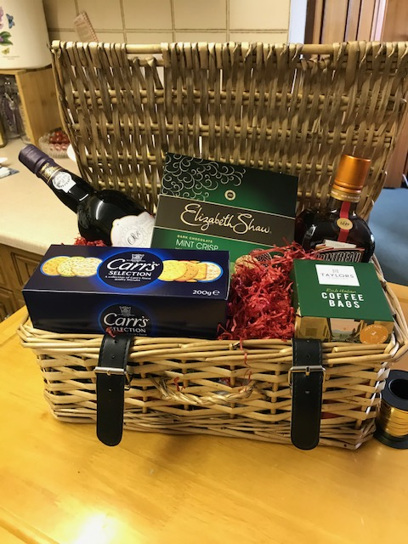 | AFTER SUPPER HAMPER  Delicious fayre, wrapped in cellophane and decorated with a bow, including Port, two kinds of Cheese (to be included fresh when your hamper is delivered) Cheese Biscuits, Cointreau, Coffee Bags and Elizabeth Shaw Mints. | Peggy Leon
21   | Weekly shopping  Nicola is happy to do a weekly shop for someone (however big or small) for 4 weeks. Just give her your list and cash and she will do your shopping for you. | Nicola Foster
22   | STRICTLY ASHBURY  4 x 1 hour Dance tuition sessions for up to 4 couples in the Village Hall. Learn Cha Cha Cha, Salsa, Blues Foxtrot and Tango. Bid as a group or individually. | Judy Clarke
23  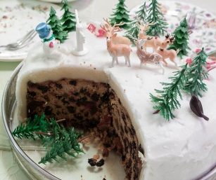 | HOME MADE CHRISTMAS CAKE  Ellen Routley has offered to bake a traditional Christmas fruit cake with marzipan, decorated with royal icing. It’ll be approx. 7 inch diameter, and perfect with a glass of sherry on Christmas evening. | Ellen Routley
24   | A DAY AT NEWBURY RACES - two premier badges  An ‘Invitation to the Races’ - 2 x premier badges (excluding Party in the Paddock and The Hennessy meetings). We can honour this for a race day from 1 July 2021 until 30 June 2022. | Newbury Racecourse plc
25  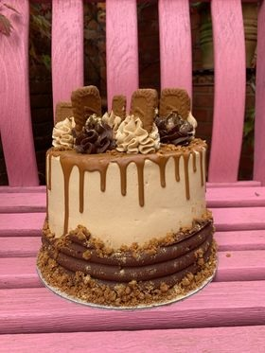 | SPECIAL CAKE FOR A SPECIAL OCCASION  Rachel from Swindon – Bunkie Bakes – will bake a beautiful, and very tasty, birthday/celebration cake for our lucky winner. You can choose from a chocolate cake with chocolate and biscoff buttercream, a chocolate oreo cake, vanilla and jam with fresh fruit and flowers, or an autumnal cake with choice of flavours (see photos on website). Cake to be made on a date for a date of your choice.  For more information about Bunkie Bakes - https://www.facebook.com/Bunkiebakes/ | Bunkie Bakes
26   | PERFUME  An unopened bottle of “Chanel No 5”, Eau de Toilette. Volume 3x20ml 1 Purse 2 refills. Condition as it left the shop | Clare McGlashan
27  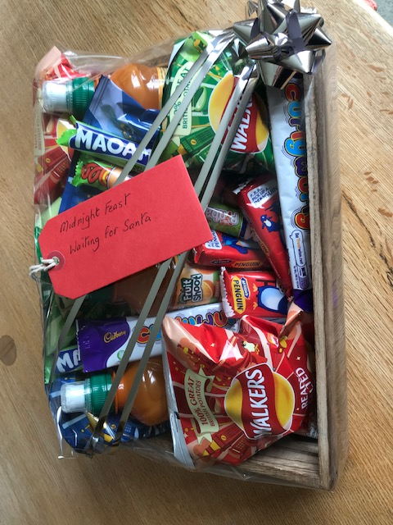 | SPECIAL CHRISTMAS MIDNIGHT FEAST HAMPER  Christmas goodies for the children – waiting for Santa!  (crisps, drinks, chocolates and sweets – all wrapped up for Christmas) | Peggy Leon
28  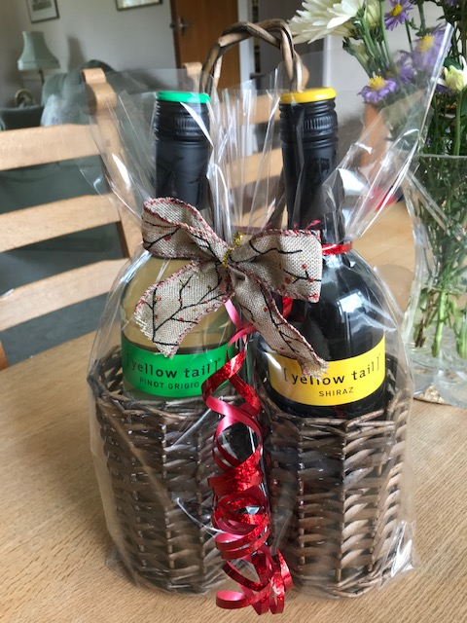 | WINE IN PRESENTATION BASKET  Yellow Tail - Shiraz and Pino Grigio – excellent Christmas gift! | Peggy Leon
29  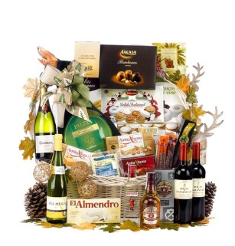 | CHRISTMAS HAMPER  A hamper with all homemade items including: damson gin, damson jelly, raspberry jam, marmalade, a small Christmas pudding, small Christmas cake, a pack of handmade Christmas cards, homemade chutney, Christmas face masks, a homemade dishcloth and free range new laid eggs. | Sue Stannard
30   | Peer-to-peer tutoring  Do you find certain subjects confusing and your teachers not much help? Sometimes talking to someone just a year or two ahead of you can make all the difference. I have just done my GCSEs and would be happy to try to help you with History, Maths, English, Geography, DT or Biology. I have also done Spanish, Chemistry and Physics, and although honestly I am not as strong in those I might be able to help there, too. Plus I can give you some test-taking techniques and other little hints. | Ta’ara Alvarez Nishio
31   | THE GINGERS  Lovely Gingerbread character felt letter decorations. Usually £3.50 each. Available in all letters. Your choice of 6. Please be aware these will be made to order once the auction has ended. https://icknieldoriginals.co.uk/ | Eliza Lewis
32  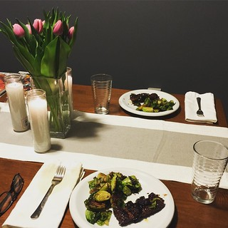 | A 3 course meal for 2 with wine  Enjoy a romantic evening for 2 at our wonderful pub  Give as a gift, or invite friends to join you | The Rose & Crown
33  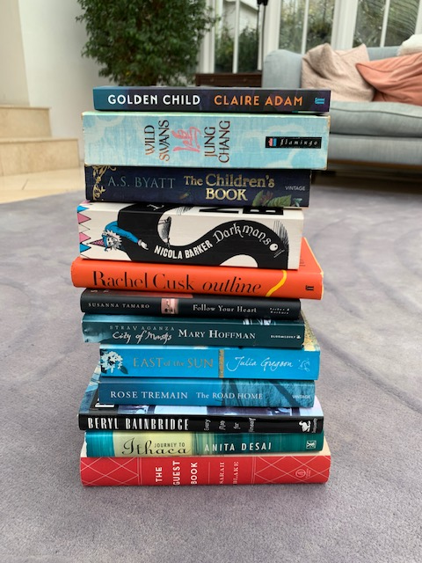 | BOOK HAMPER NO 1 (AT LEAST 6 BOOKS)  Famous Ladies  Immerse yourself in a dozen books of (mostly) fiction from a range of new and well-established female authors from Britain and around the world  (All books once read and much enjoyed.) | Anica Alvarez Nishio
34   | BOOK HAMPER NO 2 (AT LEAST 6 BOOKS)  Across the pond  Over half a dozen books by some of American’s most famous male authors and a sprinkling of new voices  (All books once read and much enjoyed.) | Anica Alvarez Nishio
35  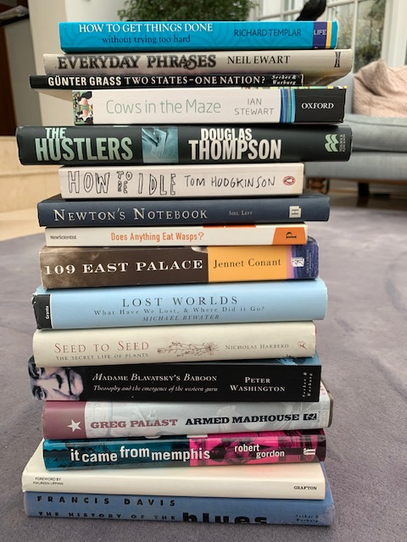 | BOOK HAMPER NO 3 (AT LEAST 6 BOOKS)  Non-fiction Nuggets  There will be something to catch everyone’ s interest in this wide-ranging collection. (All books once read and much enjoyed.) | Anica Alvarez Nishio
36 | Local Talent  Some of the finest fiction from British men  (All books once read and much enjoyed; delivered as is or properly wrapped for Christmas) | Anica Alvarez Nishio
37   | BOOK HAMPER NO 4 (AT LEAST 6 BOOKS)  Crimes and misdemeanours  A selection of detective fiction. (All books once read and much enjoyed.) | Anica Alvarez Nishio
38   | Round the World  From the steppes of Asia to the back roads of America, a wide-ranging selection of travel writing — perfect for those days spent close to home  (All books once read and much enjoyed; delivered as is or properly wrapped for Christmas) | Anica Alvarez Nishio
39   | Freshly Cooked Food for your Freezer  'Four portions of Thai Chicken Curry freshly cooked and ready to freeze' | Nicola Foster
40   | Freshly Cooked Food for your Freezer  'Four portions of Butternut Squash Soup freshly cooked and ready to freeze' | Nicola Foster
41  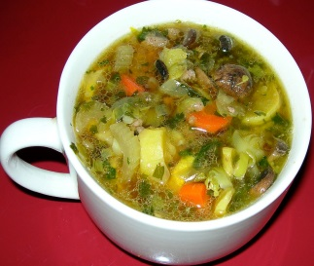 | Freshly Cooked Food for your Freezer  'Four portions of Leek and Potato Soup freshly cooked and ready to freeze' | Nicola Foster
42  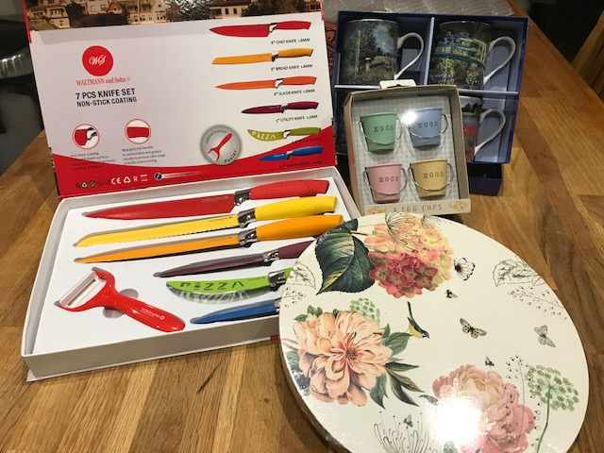 | Kitchen/Dining Bundle  Set of kitchen knives  4 Floral table mats  4 egg cups  4 Monet coffee mugs  All in presentation packs | Mary Davies
43   | Log Splitting  Have you got logs that need splitting? Mick has an electric log-splitter and is offering four hours of log-spitting at Manor View, Berrycroft | Mick Stannard
44  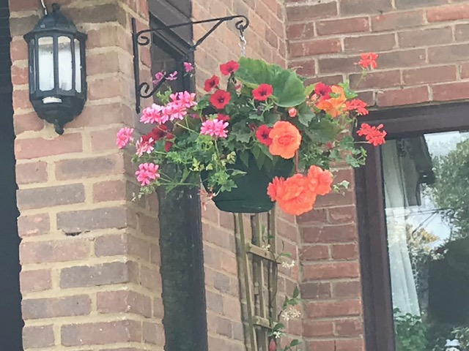 | Hanging Basket for Summer 2021  Sue will produce a lovely hanging basket ready for May/June 2021 - similar to the photo | Sue Stannard

All will remain secret until the bidding envelopes are opened on Saturday 28th November. Winners will be notified during the following week and given instructions on how to pay (no cash or cheques in the envelopes please). GOOD LUCK!
All proceeds from the Auction will go towards the funding of maintenance and repairs to our beautiful church, St Mary’s Ashbury. Thank you so much
Hopefully the Christmas Bazaar will be back next year!

